**Topics: Descriptive Statistics and Probability**

1. Look at the data given below. Plot the data, find the outliers and find out $μ, σ, σ^{2}$

|  |  |
| --- | --- |
| **Name of company** | **Measure X** |
| Allied Signal | 24.23% |
| Bankers Trust | 25.53% |
| General Mills | 25.41% |
| ITT Industries | 24.14% |
| J.P.Morgan & Co. | 29.62% |
| Lehman Brothers | 28.25% |
| Marriott | 25.81% |
| MCI | 24.39% |
| Merrill Lynch | 40.26% |
| Microsoft | 32.95% |
| Morgan Stanley | 91.36% |
| Sun Microsystems | 25.99% |
| Travelers | 39.42% |
| US Airways | 26.71% |
| Warner-Lambert | 35.00% |

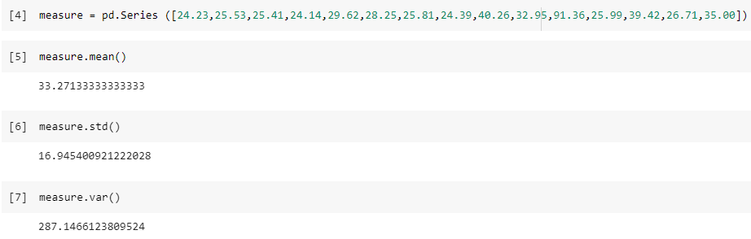

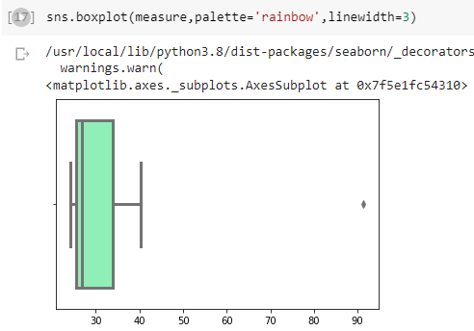

OUTLIER = 91.36



Answer the following three questions based on the box-plot above.

1. What is inter-quartile range of this dataset? (please approximate the numbers) In one line, explain what this value implies.

**IQR = UQ - LQ**

**= 12 -5**

**Inter-Quartile Range = 7**

**The IQR describes the middle 50% of the data values when ordered from lowest to highest.**

1. What can we say about the skewness of this dataset?

**From the above boxplot we can say that it is slightly positively skewed because the length of the right tail is longer when compared to the left tail.**

1. If it was found that the data point with the value 25 is actually 2.5, how would the new box-plot be affected?

**In that case we would not have the outlier and the new boxplot will have more positive skewness.**



Answer the following three questions based on the histogram above.

1. Where would the mode of this dataset lie?

**Since it is a bimodal distribution, we have modes i.e., 5 and 7**

1. Comment on the skewness of the dataset.

**Slightly Positively Skewed**.

1. Suppose that the above histogram and the box-plot in question 2 are plotted for the same dataset. Explain how these graphs complement each other in providing information about any dataset.

**Boxplot explains clearly that there exists an outlier clearly whereas Histogram cannot explain it clearly.**

1. AT&T was running commercials in 1990 aimed at luring back customers who had switched to one of the other long-distance phone service providers. One such commercial shows a businessman trying to reach Phoenix and mistakenly getting Fiji, where a half-naked native on a beach responds incomprehensibly in Polynesian. When asked about this advertisement, AT&T admitted that the portrayed incident did not actually take place but added that this was an enactment of something that “could happen.” Suppose that one in 200 long-distance telephone calls is misdirected. What is the probability that at least one in five attempted telephone calls reaches the wrong number? (Assume independence of attempts.)

**Ans: = Probability of call misdirecting p = 1/200**

**= Probability of call not Misdirecting = 1 - 1/200 = 199/200**

**Number of Calls = 5**

**P(x) = ⁿCₓpˣqⁿ⁻ˣ**

**n = 5**

**p = 1/200**

**q = 199/200**

**at least one in five attempted telephone calls reaches the wrong number**

**= 1 - none of the call reaches the wrong number**

**= 1 - P (0)**

**= 1   - ⁵C₀ (1/200) ⁰ (199/200) ⁵⁻⁰**

**= 1 - (199/200) ⁵**

**= 0.02475**

**probability that at least one in five attempted telephone calls reaches the wrong number =**

**0.02475**

1. Returns on a certain business venture, to the nearest $1,000, are known to follow the following probability distribution

|  |  |
| --- | --- |
| x | P(x) |
| -2,000 | 0.1 |
| -1,000 | 0.1 |
| 0 | 0.2 |
| 1000 | 0.2 |
| 2000 | 0.3 |
| 3000 | 0.1 |

1. What is the most likely monetary outcome of the business venture?

**Ans = 2000**

1. Is the venture likely to be successful? Explain

**We can say that from the data the Probability of getting successful return is more than**

**Losing the return (1100-300) =800**

1. What is the long-term average earning of business ventures of this kind? Explain

**800$ is the long-term avg.**

1. What is the good measure of the risk involved in a venture of this kind? Compute this measure

**Risk stems from the possible variability in the expected returns. Therefore, a good**

**measure to evaluate the risk for a venture of this kind would be variance or standard**

**deviation of the variable x.**

**Here,**

**Sd=1870 and var=3500000**

**The large value of standard deviation of $1870 is considered along with the average**

**returns of $800 indicates that this venture is highly risky.**